No More Lonesome Rhodes

If we choose to listen ...  We can hear Rod Serling welcome one Lonesome Rhodes, a traveler from another time and place, to this year's version of the big dance.  Mr. Rhodes, our most senior political consultant, first introduced himself in a little old film called A Face in the Crowd way back in 1957.  Based on a short story by Budd Schulberg, it did not receive much of a reception. |   Punch Lines and Glamour

If we look between the lines, however, we may find some fraction of the insight required to understand how we arrived at the current state of electoral affairs in these United States of America.
For those who have not met him, Mr. Rhodes is a good ol' boy from Arkansas who has an ear for a bawdy tune. The movie begins when he is discovered sleeping one off in the local jail by Marcia Jeffries, a radio producer in search of some talent. She thinks he may be just the sort of character she can use to keep some part of the jaded audience that is busy migrating to the "hot" new media of television.
After Rhodes belts out a quick tune, Ms. Jeffries gives him the stage name of Lonesome, and the Sheriff turns him out. Rhodes quickly builds a following on the air with his picaresque honesty, and then nominates his reluctant foil, the Sheriff, for a term as the local dogcatcher.
Lonesome wants the Sheriff to prove his mettle before anyone takes his bid for Mayor a little too seriously. To support this bit of "grass roots democracy," Rhodes asks his audience to bring all the local stray dogs to the Sheriff's yard, which prompts him to withdraw from the race in favor of a little peace.
A talent agent gets wind of his show, and offers Lonesome a spot in the hot new television market in Memphis. Unleashed in a new channel, he immediately upsets a local sponsor by turning him into an easy punch line. In exchange for some part of his ego, the sponsor realizes a 55% jump in sales, and learns how to raise his bottom line by choking down some of his pride (a recurring theme).
After establishing his brand, Lonesome significantly expands his market by moving on up to the Big Apple.

In the city, Lonesome pushes a different product, becoming the pitch man for Vitajex, a pill that will "give a fella the get up and go." The ad campaign scene is a classic, showing us how the American public applauds each new dog and pony show, and how we all do our part to keep the show rolling. | 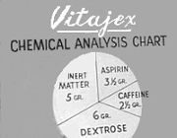
Lonesome's new act plays pretty well from not-too-far off Broadway, and he finds the nation has developed a bit of a crush on him.

Sudden fame brings new friends and old benefits. Invited to judge a baton-twirling contest, Lonesome finds the girl of his dreams. With a quick side trip to Juarez, Rhodes trades in his cherished freedom in the morning for a serious bump in his ratings.  Just as the audience grows uneasy watching his new Arkansas peach high-stepping around the set of Lonesome's hit show, things start to get very dark.  First, Marcia gets to meet the first wife: the one Lonesome left behind many years ago. We learn that she is only after a modest slice of that new pie Lonesome has cooling on the window sill, and we get the sense that she has earned it.  After receiving an object-lesson from the first Mrs. Rhodes, Marcia gets assertive about her stake in the network show. She wants a cut, and some say over the direction things will go, which is only fair.  Lonesome quickly finds himself caught between three versions of the feminine -- the naive, the jaded, and the managerial -- and he is unable to really connect with any of them.  In the next scene, we meet Senator Worthington Fuller, who retains Mr. Rhodes for a special sort of consulting service. He wants Lonesome to help him connect with as many unattached voters as he can, so he can grab that big job on Pennsylvania Avenue.  We are shown that Fuller has been promoted as the mature, serious and more traditional candidate ... and he has turned to Lonesome because it's not really working.  Lonesome advises the Senator that the public is not interested in the wisdom of elders: what they want is someone they can love, if not respect. "Politics," as Lonesome points out, "is people," and citizens often vote with their hearts.  It comes as a bit of a shock to the candidate. We don't like to admit that the electoral college may be driven more by affect than reason, and that our votes may be used to decide who we think is most likely to succeed.  In short order, Lonesome advises the Senator to get a dog, loosen his jaw, speak in the local vernacular and get some good old boys to serve in a friendly Greek chorus.  The message connects, and the Senator gets on board with a new and different campaign. With a guest spot on Lonesome's new show, the Senator grabs a little chew, and starts spittin' out a series of glossy punch lines around the old Cracker Barrel.  The strategy works, and the Senator starts climbing up in the polls. Lonesome starts to swell up with his new found power, and proposes a new cabinet-level position for himself in the Fuller administration: the Secretary of National Morale.  Before Rhodes can assume a different role on the national stage, Marcia precipitates the climax by leaving a "hot" microphone open while the credits roll on the show. Lonesome lets his true colors fly, referring to his adoring public as "idiots, morons, and guinea pigs."  The reaction is immediate. Before he can leave the building, Lonesome is sent down a greased chute to a pit of pedestrian obscurity.  As he rants and tilts against the vagaries of instant karma, another foil played by Walter Matthau intones that "we get wise ... that's our strength ... we get wise." The line is delivered quietly, as if he isn't sure that it will hold much water.  The film is prescient, and also of a piece with its time. In some measure, it foreshadows the growing artifice created by the medium, and also reflects the lessons learned in the current election.  Dwight Eisenhower was the first to adapt to the channel, and the most adept at presenting the figure of a trusted paternal leader. He helped to define the modern archetype of "adult leadership," something we all recognize even if we dislike it.  While Adlai Stevenson's campaign manager decried the effort to sell Eisenhower in the same manner as "soap, hair tonic or bubble gum," every candidate has relied on Madison Avenue to gain the office.  Nixon learned the hard way. The Checkers speech may have given him a false sense of security going into his televised debate with JFK, and he paid for his lack of stage foundation with an election. A new father, one with young kids and a great deal of confidence, fit the zeitgeist.  LBJ stepped into the job in a crisis. He didn't quite look the part: he was everyone's loud Texan uncle, the one with big ears, and yet, he managed to fill the shoes pretty well. Despite the easy assumptions people made based on the imagery, sometimes he did the right thing when backed up against a wall.  In 1964, Barry Goldwater challenged LBJ and it was obvious which candidate could sell more soap, hair tonic and bubble gum. It wasn't the incumbent. The race still occupies a special place in the history of advertising, due to the appearance of the infamous "Daisy" promotion.  The little girl counting down as she plucked the petals of a flower captured the attention. The mushroom cloud at the end made an indelible impression. The contrast between the mundane and the apocalyptic, the innocent and the damned, and the open question of global responsibility tipped the playing field.  Goldwater failed to take on the "adult" part of his representation seriously enough; LBJ did not. Loose rhetoric in the age of Dr. Strangelove could shred political credibility like no other gaffe. The "nuclear question" remains a key litmus in every election.  The 1968 campaign marked the return of Mr. Nixon, seasoned and served up by one Roger Ailes. They went with both long-form promotional content and the more traditional town hall meetings that played to Nixon's skill set. He wisely refused to debate, and took the office in a close race.  The 1972 race kept the abusive father we knew in place, and left Shirley Chisholm out in the cold. In some better, alternate universe, she won and took all the boys out behind the barn.  Things folded pretty quickly after the election, and Ford wound up holding the bag. Carter revived the debates, and it helped him take a close race in the bicentennial year.  America embraced a calm and devout Southern leader to atone for the dysfunction of Nixon. On camera, he projected the easy competence of a really nice stepfather.  Like a difficult teenager, we had to rebel against the new Dad. We reached out for the slow and easy grandpa who offered to put us up for the summer. We knew that he liked to go to bed early, and that would let us sneak out and party all night long.  Now, we may not like how Roger Ailes, Lee Atwater and their cronies help the lesser candidates get the office, but we should admit they know which notes to play, and in what order. The scripts worked, and the opposition could not respond effectively.  The first Bush inherited the office after dismissing a more intelligent candidate who, unfortunately, did not quite look the part (too ethnic). It taught us to accept that competence and character were no longer key predicators for success.  The cycle repeats, and a different new father with a young child and a lot of confidence took center stage. Clinton came from the wrong side of the tracks, which gave him a certain authenticity the established plutocrats could not match.  It was close, and Perot almost took us through the looking glass, but we found a new dad we thought we could trust. Sure, he was marked by the 1960s, but he was a real grown up (er, Fleetwood Mac?).  In 1996, Bob Dole became the last candidate from the greatest generation to make a run, and his age proved a key liability. And so the torch was formally passed to the boomers ...  Who immediately drove the car off the road. In 2000, Gore tried his hand at the Ward Cleaver role, but the populace knows a too-stiff neck when it hears someone talk about inventing the Internet.  With a few hanging chads, Bush became the new step-dad, the not-so-bright follow up to the louche intellectual. Somehow, GW and Laura managed to restore some of our faith in the power of marriage.  We watched and learned in 2001. Well, we survived the trauma and watched the less savory element try to wear the big boy pants. They didn't fit so well, and when we finally left the trauma ward in 2008, we lucked out.  Obama has redefined adult leadership in our age. With his calm, competent demeanor, his refined intellect and rational direction, he has truly raised the bar for all who may follow. We will miss him.  And now we find ourselves on the precipice, and must choose between the older matriarch and the jackass. There is no paternal voice, only the bluster of an arrested adolescent who thinks the world should listen because he is not of the political class.  Trump identified Roy Cohn as his mentor early in his career. For anyone not familiar, Cohn started out as Eugene McCarthy's right hand in the HUAC hearings, and grew into a career as one of the most feared and reviled lawyers of his generation.  Cohn was notorious for playing hard and low, and for never apologizing. Trump has internalized the perverse logos of the man he once followed, and discovered that he can "fail up" through a process that will select out any adult competent enough to hold the office.  Hillary offers mature leadership, albeit one that seems bereft of any concrete political philosopy. She generally falls on the humanistic side of the coin, and that offers enough hope to win my vote. Ideally, she should have gained office in the 1992 race (we may have, in the last analysis, put the wrong Clinton in the White House in those days).  Given the alternative, it is well-past time we let the glass ceiling fall. Yes, we all wish the younger, more idealistic version of Hillary was still around, but we can work with the older, wiser version that we find on the ticket.  This election is, in some measure, a referendum on the value of the reality principal. While Trump in the White House would, no doubt, offer a great deal of decadent pleasure in the tradition of Nero, democracy must find a way to confront external reality and put a check on our collective Id.  The First Lady made it explicit, and said it in the best Mom tone. We really do need an adult in the White House. We cannot get down with Lonesome Rhodes, and we cannot turn the highest office in our land into the set of a b-list program.  As Mr. Trump has discovered, the microphone is never off, and the whole world is watching. | 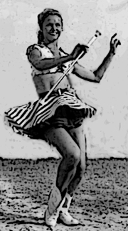  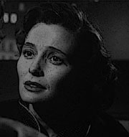  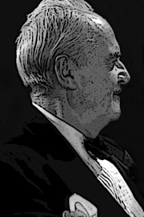  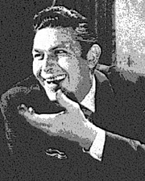  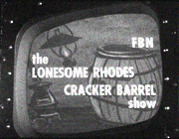  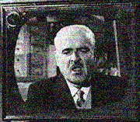  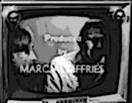  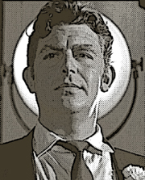  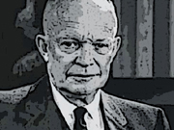  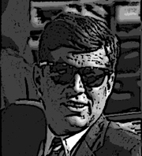  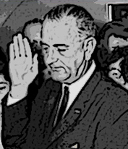  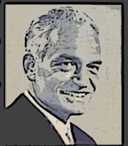    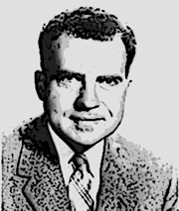  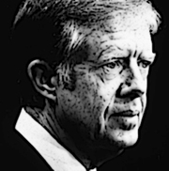  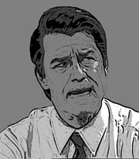  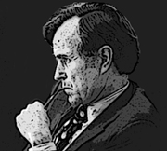  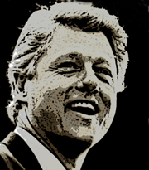  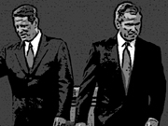  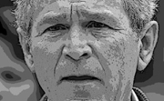  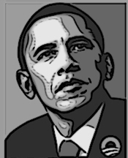    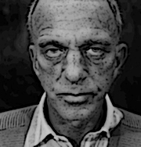  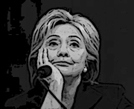    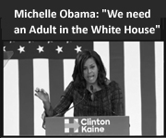  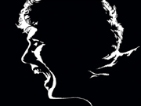

Steven Peterson, 2016



