Not Just Another Silk Purse

On the day after the Inauguration, it was time to hit the market for the weekly haul. While pushing my cart through the store, I glanced into one of the meat cases, and stopped cold.  The butcher had put out several hundred frozen Pig Ears, too many to simply ignore. Generally, I do not look for signs from above in the grocery store, but this one defied any kind of easy explanation.  Over the years, I have spotted a few ears hiding out in a dim corner, but never before so many, nor in such a high profile location. And the price, at about two dollars an ear, somehow made it feel even more ominous.  There aren't many culinary options for these leathery bits of skin and cartilage, certainly not enough to warrant such a hoard.  Could there be a glut? We all know pork bellies have some kind of future, but what could drive a demand for so many ears?  And then, of course, the headlines started. Executive orders, perverse cabinet picks, schoolyard arguments over crowd size and the integrity of the popular vote. A new strain of bull in our collective china shop.  A quiet echo of snorting and squealing, and the start of the big slop. A dim memory of Animal Farm, and of its windmills, hens and sheep. In addition to nostalgia, etymology offers a semantic spark ... | 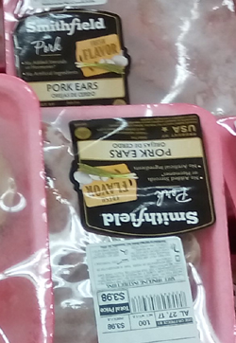  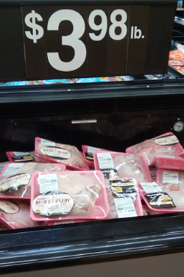
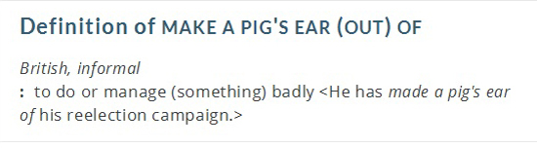
Ah-ha! I couldn't bring myself to look for any other cuts, but it felt right. We are, no doubt, in for a master class in how to make a real pig's ear out of our government.
How did we get here? Who is this executive, why is he shredding everything in his path, and what can we do about it?
Many have tried to diagnose the 45th, to sketch a profile that might shed some light. Any reasonable observer can see the broad strokes: highly narcissistic, privileged life, not so good with women or children. Not quite syphilitic, at least not yet, and a true shining example of how grade inflation comes to a bitter end.
In another essay, I had the temerity to note that the election of 2016 was, "in some measure, a referendum on the value of the reality principal" and that "democracy must find a way to confront external reality and put a check on our collective Id." There are some complicated ideas bouncing around in those statements, and it may help to spell things out a bit. Let's begin with a traditional map of the human psyche:
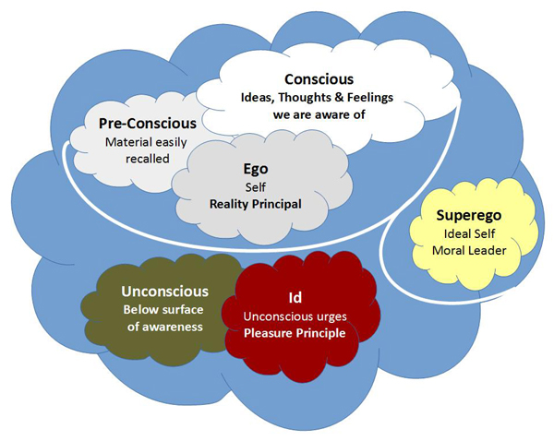
Like most people, the 45th struggles to keep the Ego and the Id in check, and probably works from the assumption that his conscious mind is calling the shots. He also seems to take every opportunity to smother the Superego. Following Skinner's lead, we should avoid the temptation to assign a simple diagnosis, especially from a distance, and do our best to monitor his behavior without prejudice or preconception. The hard part is accepting that he is a lot more like the rest of us than anybody would like to admit.
Papa Freud argued that we can identify maturity by an ability to endure the pain of deferred gratification. In his view, "an ego thus educated has become 'reasonable'; it no longer lets itself be governed by the pleasure principle, but obeys the reality principle, which also, at bottom, seeks to obtain pleasure, but pleasure which is assured through taking account of reality, even though it is pleasure postponed."
So far, the 45th does not appear willing to postpone anything, or to acknowledge any kind of a shared reality before he acts. Call it a first impression: his personal history does not offer much hope for putting a check on the Id (his or ours), or upholding the reality principle in a substantive manner.
Recent observations may lead us to consider ideas from R.D. Laing, who offered a model in The Divided Self which seems to map closely to our new Executive. In Laing's model, a healthy person inhabits an "embodied self" that engages with others in the world in a meaningful manner. This produces authentic perceptions used to maintain a stable psyche and a healthy family or culture.
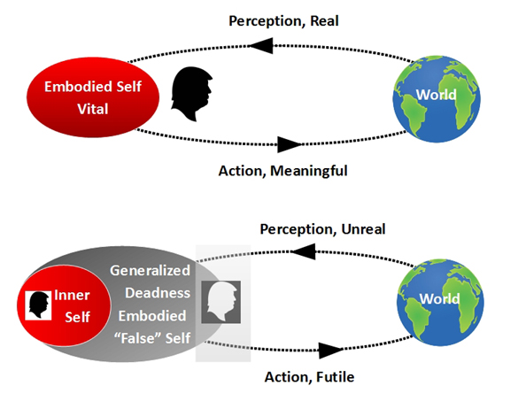
In contrast, Laing defined a "schizoid condition" that lacks a direct relationship to reality. In this model, the inner self is intermediated by a "false self" that embodies a "generalized deadness" that is both narcissistic and necrophilic. To protect the inner self, the public self will distort perception or misdirect action. Energy is drained from the inner self by this effort, and may wither and start to fear death.
Laing viewed this schizoid condition as a coping strategy or response to an insane world, as opposed to a symptom of an innate disease of the psyche. Lacking a case history, we may infer a set of conditions prompted such a response, if we agree with Laing, or we may reach for an alternate diagnosis based on new observations.
Given his public behavior, one could argue the 45th fits the schizoid model, albeit in a "high functioning" manner. Behind the persona we find in the daily news, there may be a human soul in real trouble, or just a skilled provocateur using a mask to advance an agenda and throw others off the scent. Either way, we can expect the headlines to keep flying: the man knows how to stoke a fire and entertain the groundlings.
So, how did we get here, and what can we learn from it?
The field of candidates in the last election was, by anyone's estimate, fairly weak. The outgoing executive, on the other hand, served as the epitome of a mature psyche. We are, once again, reminded that things do fall apart, and the center does not hold. The Id will assert itself in pursuit of the pleasure principle and have its due; we can only hope the social structure can weather that storm.
With the advent of modern media, we have watched the electoral process mutate into a contest for ratings. The science of marketing has blossomed, and we have embraced the chimera of statistical analysis. This combination offers just enough distraction and cover to justify any option, and we are still pretty lazy after all these years.
OK, not so much lazy as overwhelmed. We are presented with an unending series of what are known as Wicked Problems. These are issues, such as banking regulation or immigration policy, that are very difficult to resolve because they are driven by incomplete, contradictory, and changing terms or conditions. We also find that any effort to solve one aspect of a wicked problem reveals or creates other problems (e.g., in that event, who will pick the lettuce?).
In short, most of the simple problems were solved a long time ago, and we are now confronted with an endless series of nested and interconnected issues. On a daily basis, we can reliably contest any simple solution that is proposed, because it has no real chance of working. And this conflicts with our communication habits, which favor short, simple subjects and clear verbs and objects.
And that is where the slogans and rehearsed lines come into play. On the campaign trail, a slick pitch and a tagline can offer the appearance of a clue, as my kids would say. It's an old shtick, but we still fall for it. At least until the executive orders begin -- and then we repent in leisure.
Stumbling toward Gehenna, we discover that it is a lot easier to let the Nielsen meter track our viewing habits than it is to take on the hard work of selecting a new head of state. And that is where expectations must be re-set. To cast a vote is to take on the responsibility of the hiring manager. It always has been, and it always shall be.
If we make a poor decision after the debates, while casting our votes, then we must hold ourselves to account. To restore the integrity of the office, we must learn to think long and hard about the questions we ask, the answers we receive, and the criteria we use to qualify and elect a presidential candidate. And no, anyone who is merely famous should not get a chance at the office. The stakes are too high, and millions of lives are at risk.
To get the ball rolling, a few basic considerations:
 |  | The office requires substantial structural knowledge of our federal government. For example, the duties and powers assigned to all three branches, the mechanics of proposing and passing new legislation, and the limits of executive power.
 |  | The office requires substantial literacy skills, including a) the ability to digest large amounts of written content, and b) the ability to write at a college level. If a candidate cannot produce any original work in prose, and cannot answer simple questions about our foundational documents, their campaign should end.
 |  | The office includes duty as commander-in-chief of our armed forces. While we cannot limit the field to those with a service record, we can insist on a working knowledge of American military history and global standards of conduct. A viable candidate should demonstrate an ability to accept input and wield authority.
In addition to the baseline skills, there are some key personality traits to watch for:
Given the level of power associated with the office, and the complexity of the challenges faced by our leader, an authentic display of humility is important. No part of the job is easy, and if a candidate thinks they have all the answers, or falls under the spell of their hubris, failure is assured.
The office and role of the President is managerial in nature, and people must be willing to work with whomever we place in the office. Some of their colleagues are elected, others are hired, and all of them deserve respect as they serve. If a candidate cannot discuss the efforts of others without resorting to ad hominem attacks or rank vilification, there is little hope for effective leadership.
The executive branch has limits -- this is intentional, and reflects the value our founding fathers placed on checks and balances. The President is a leader, not a dictator, and is expected to operate with constraint when wielding power and influence. A candidate who does not recognize the limits of the office, or makes outlandish campaign promises, should not receive the nomination, much less our vote.
We may never agree on what a complete job description for the President would look like. There are just too many skills and challenges involved, and no one would fit the bill if we accounted for all aspects of the position. We can, however, reach consensus on what a minimal set of knowledge, skills and behaviors for the office will include.
The short list defined above offers a starting point. Add as many baseline abilities and character traits as you think are required. Again, we are the hiring managers in this electoral scenario, and we need to accept the burden that entails. It will never be an easy decision, and we need to give it far more thought than may be carried in a ninety second ad, or in a clipped response to a "debate" question.
Once again, etymology offers a semantic spark ...
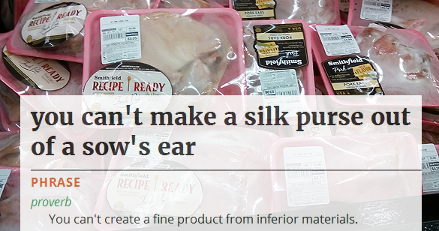
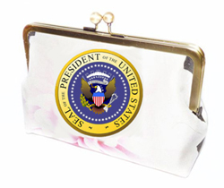
The pig ears just will not go away. We must consider the quality of source material we select when weaving the most important silk purse in our republic's wardrobe.
The rest of the world has more than a passing interest in the decision we make, and all of humanity expects us to take the job seriously.

May we show our descendants that we have learned something in this election cycle. With 20/20 vision, let us send Roy Cohn's shade back to the shadow realm, where it belongs.
-- Steven Peterson, 2017

